**Super Market Billing System**

Solution Layout

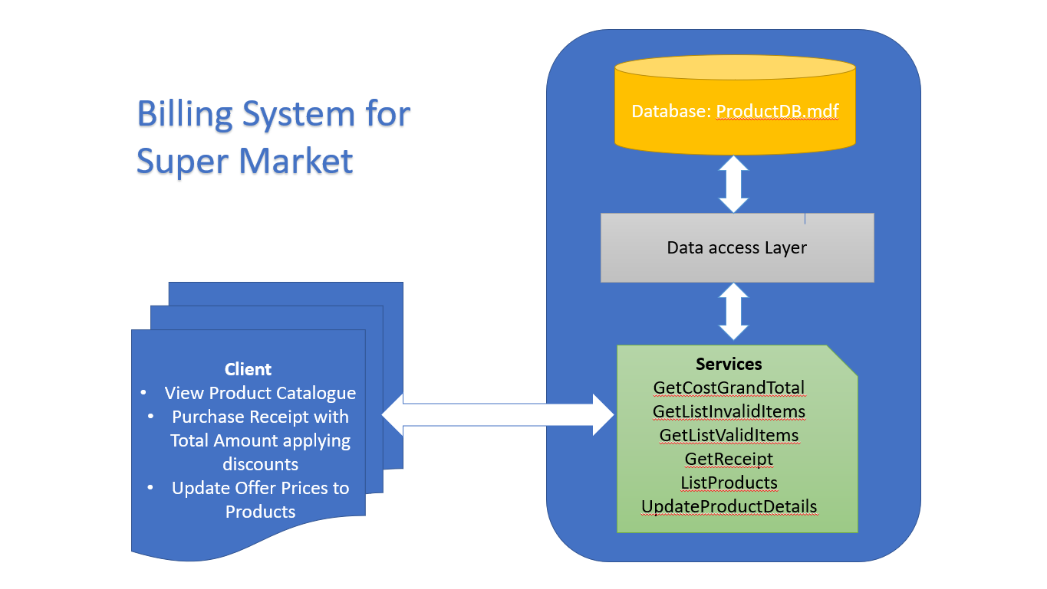

Solution Set up

## Steps to run the Service:

1. Open the "MarketBillingService" solution via. Visual Studio ( For Development, I have used VS Community 2017 v15.9.5 ).
2. **Mandatory** to "Clean and Rebuild" option in the solution
3. Open MarketBillingSystem.asmx file from the solution and run it.
4. Your web service will be launched in your browser. Please make note of it for configuring service in the client.

Eg. [http://localhost:58188/MarketBillingSystem.asmx](http://localhost:58188/MarketBillingSystem.asmx%20)

1. You will see the list of below services available to invoke in (Details of the Service functionalities stated below).

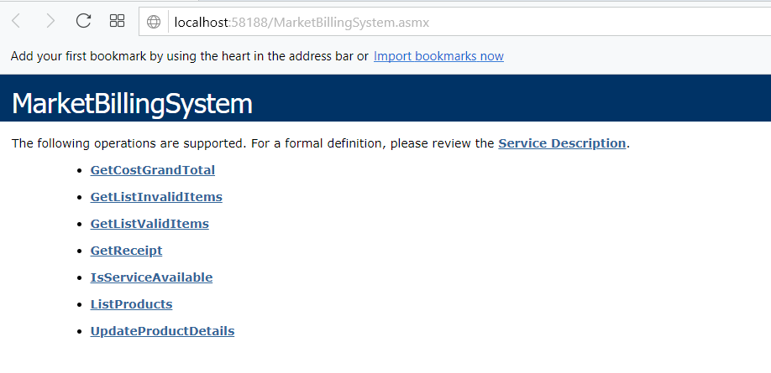

1. Now Open Project **BillingClient** Solution in Visual Studio another session.
2. Right click on Service and select Configure Service Reference

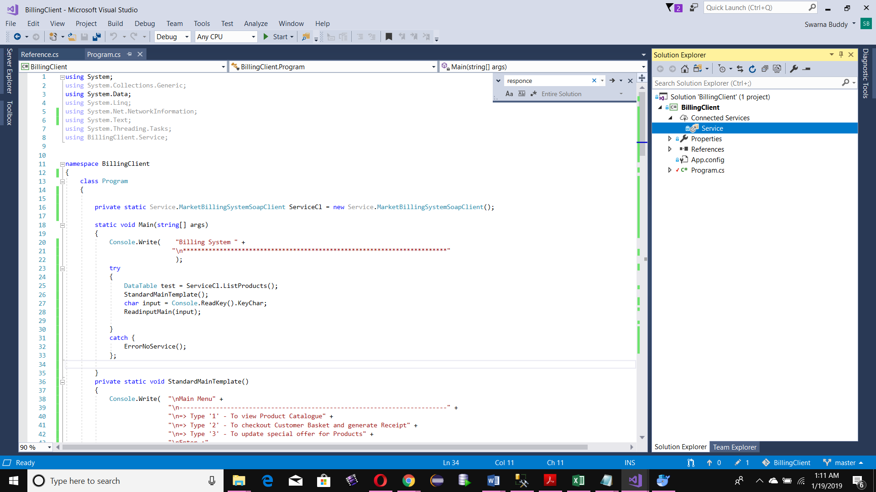

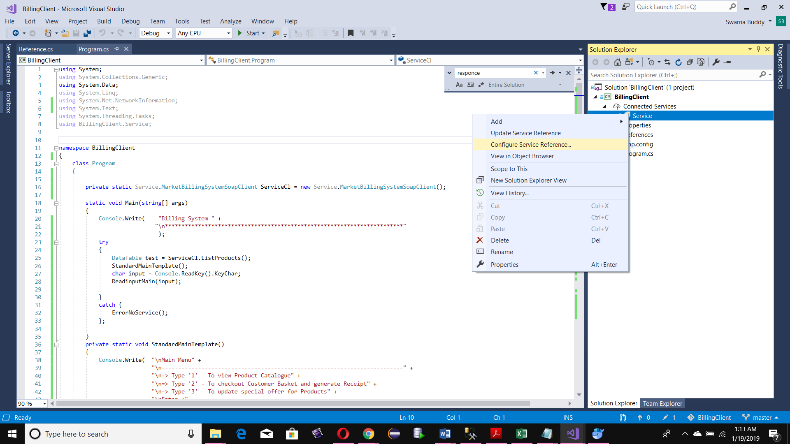

5.In the Address enter the localhost url of Web Service running in your machine (noted in the previous step). Click OK

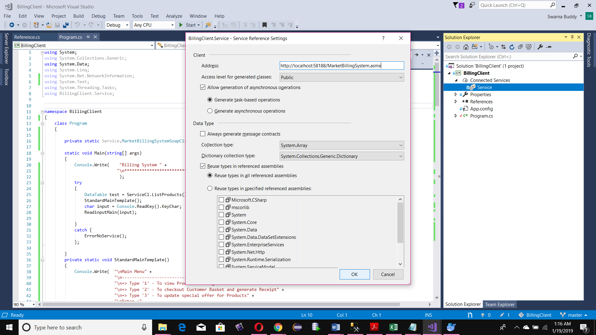

1. Now run BillingClient Console application
2. If your service is not running, You will see the below screen

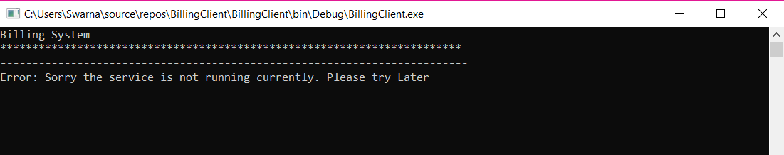

1. If your service is running at the background you should see the below screen in console

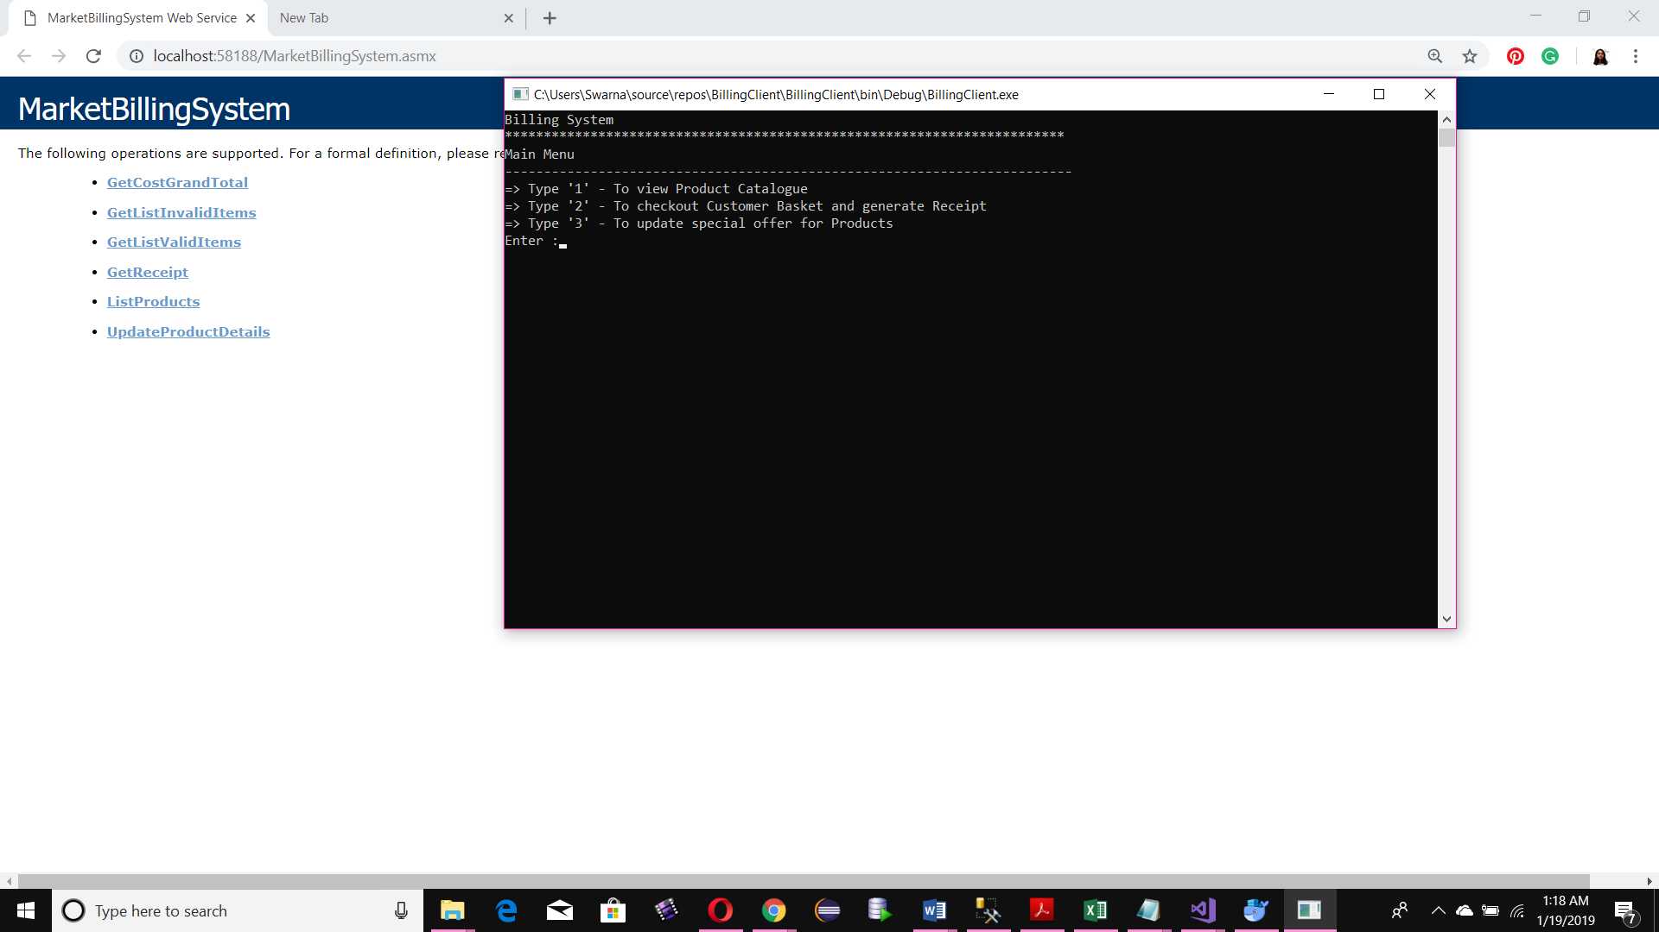

1. Now enter inputs to Client as per prompt

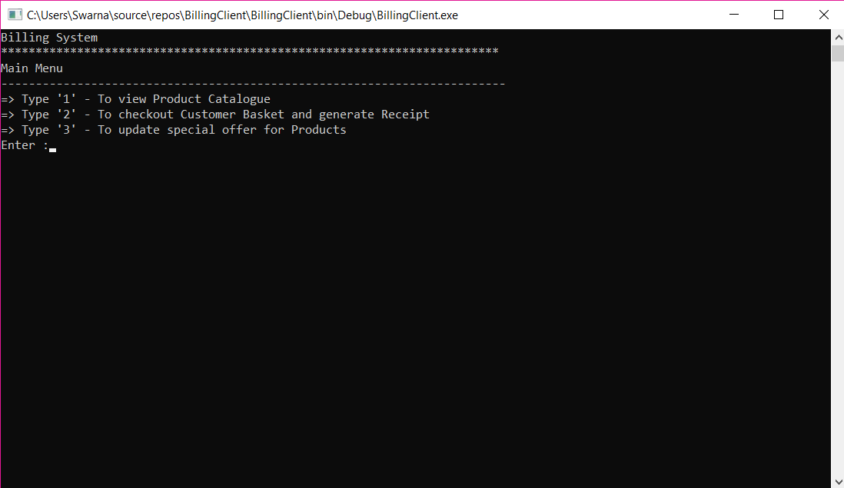

# Menu 1: To View Product Catalogue

## Result

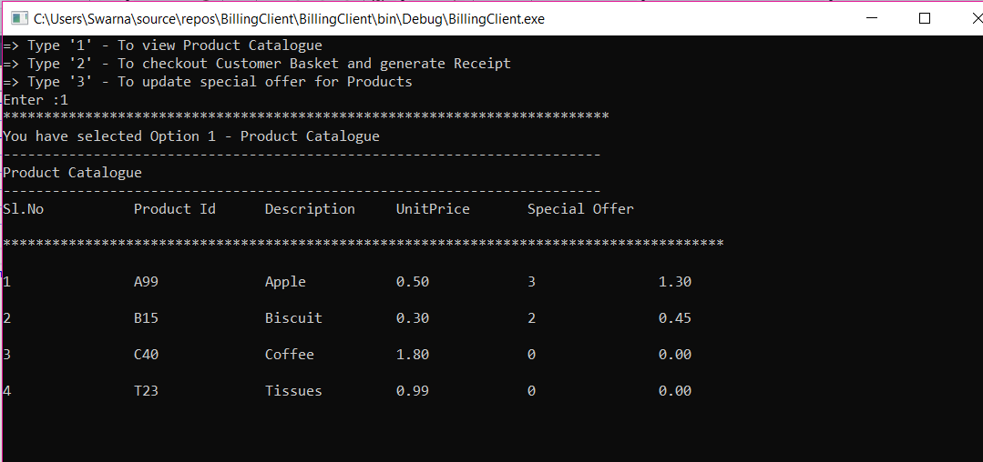

# Menu 2: Checkout Customer Basket and generate Receipt with Total Price inclusive of discounts

## Result

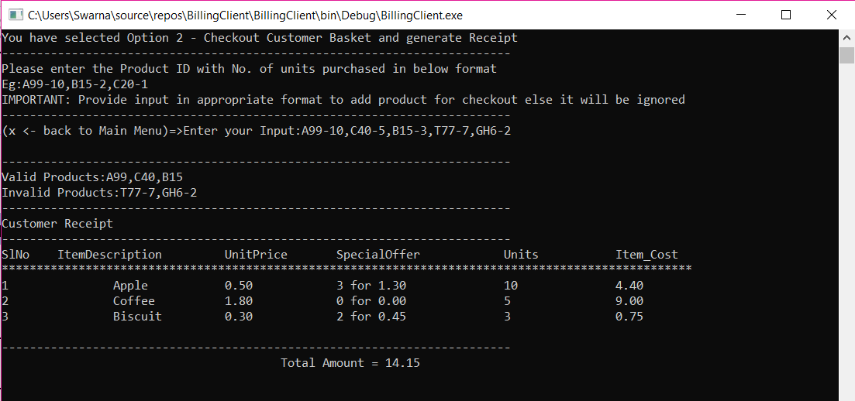

# Menu 3: Update Offer details

## Result

